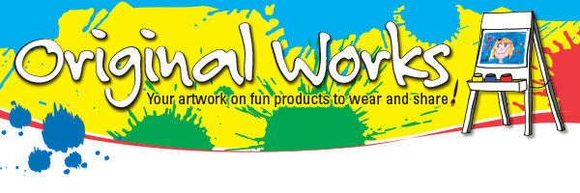
Dear

Thank you again for choosing Original Works!

At the time you confirmed your program you were sent an email containing your Confirmation, which includes your schedule. Now is a great time to review the contents of that email. We recommend you keep this email for reference.

Your supply package from Original Works has been shipped according to your schedule. If you have not received the package by your scheduled ‘receives program materials’ date please contact me. Once the package arrives please open it and inventory its contents. There is a hardcopy of your Coordinator’s Guide included. Please keep this on hand for reference.

To review the newly updated “Art Instructions” for Single Step SBYB click here. They are also included in your Coordinator’s Guide. The instructions have been updated with more detail to assist you in making sure your school’s artwork meets our requirements. Please forward a copy to the art instructor so that he or she may review them.
Click here to see our e-Marketing Kit Guide to begin promoting your program.
Please make copies and distribute the “Look What’s Coming” letter early in your program. For Single Step SBYB click here.

To further promote the program, remember to:
- Display the poster(s) we’ve provided you.
- Utilize the morning announcements and the school newsletter.
- Post information on your school’s website and/or social media platforms.
- Create your own promotional reminder to send home to the parents.

Should you have any questions please call your sales representative. Your password to enter Customer Care Site for Forms & Lesson Plans is CCC1314. We are excited to work with you!

