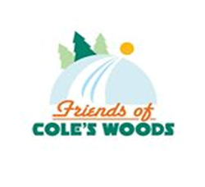
Bill Parks’ race over the Norwegian Mountains in support of Cole’s Woods!

HOW TO CONTRIBUTE:
Name: ________________________________
Street: _______________________________ City: __________________
State: _________ Zip Code: ____________ Phone: _________________
E-mail: ________________________________
CONTRIBUTION OPTIONS:
Go metric!… 54kilometers X ____________ = _____________
(Name an amount/km) (Total contribution)
OR …
Go English!... 34 miles X ____________ = _____________
(Name an amount/mi.) (Total contribution)
OR …
Name your contribution: $ ______________

THANK YOU:
Thank you for your support of our trail system and the many healthy recreation activities it provides. Please make checks payable to: Friends of Cole’s Woods. All contributions are tax exempt.
Mail to: Friends of Cole’s Woods - P.O. Box 294 - Glens Falls, NY 12801
Contributors donating $25.00 or more will receive a Friends of Cole’s Woods membership.

