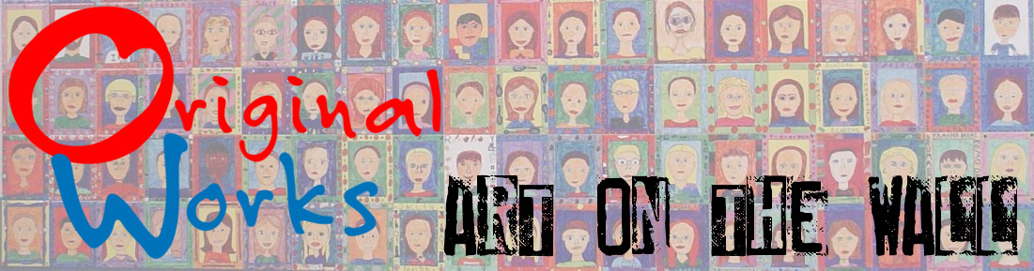

School Code:
XXX

Dear
«Contact_Firstname»:

We are excited to be working with you this year! Throughout the program you will receive periodic emails from me to keep you on track.

When you confirmed your program you received an email that has your Confirmation including your program schedule. Be sure to review the contents and save the email as you will need to refer to it throughout the program.

We’ve shipped your supply box according to your schedule. If you don’t receive the package by the scheduled date, please contact me.

I’ve attached a copy of your Coordinator’s Guide that will take you step by step through the program.

I also recommend that you login to our Customer Care Center. The password is: CCC1617. You will find lesson plans, art ideas, forms and eMarketing & promotional ideas to help make you fundraiser a success!

This is a great time to print the “Look What’s Coming” letter and send home to families announcing the program. You will also want to print and distribute the “Reserve Your Spot on Our Wall” letter, to families.

Should you have any questions don’t hesitate to call your Territory Representative.

