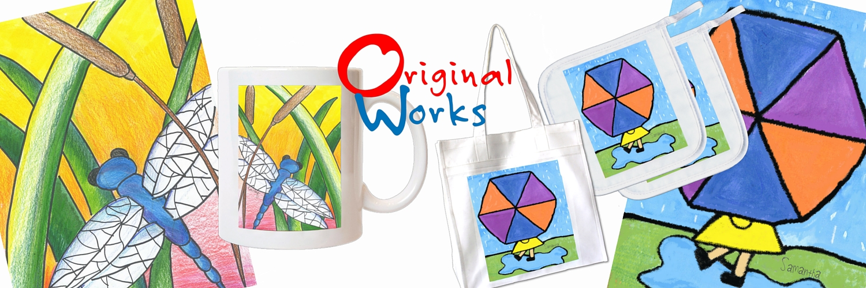

School Code: XXX

Dear
«Contact_Firstname»,

Another deadline is quickly approaching! It’s time to send your artwork and orders to Original Works. If you are behind schedule please contact me immediately.
To ensure your program is a success, here are a few tips & tricks!
- Double check and make sure all artwork is on 8.5 x 11 inch paper.
- Be sure to follow the art guidelines, and call us if you have any questions:
    - Check that no abrasive (sand or salt), no fluorescent or neon colors, no metallic materials (glitter, glitter paint, glitter glue, or foils, etc.) are used. The artwork should have the child’s name, teacher and grade on the back using labels or written in pencil.
- Organize artwork by teacher/class and then grade.
- Order forms should be taped to the back of the artwork (only 1 artwork per order form please). Please, attach the white copy and retain the yellow copy for school records. Customer service requires order form number for reference.
- Please use folders to keep the orders/artwork separated by class/grade. Wrap folders in plastic bag(s) to protect during shipping
- The attached shipping form must accompany your artwork shipment.
- Send your artwork/order package on the scheduled ship date using a traceable carrier, such as UPS or FedEx. Please note that artwork arriving after the scheduled date may take longer to process and deliver.
If you have any questions, feel free to refer to your Coordinator’s Guide, our website, or contact me directly.

«SIGNATURE»

