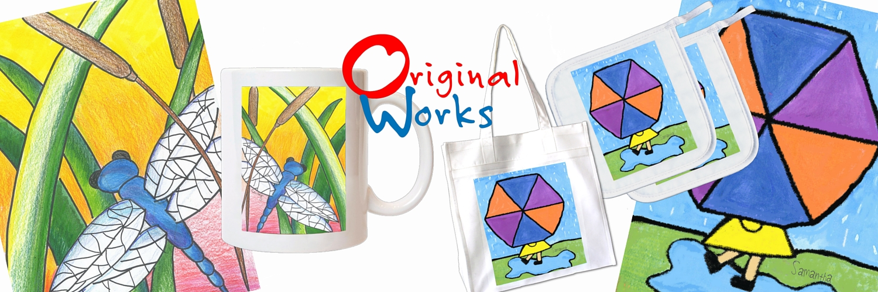

School Code: XXX

Dear
«Contact_Firstname»

Another deadline is quickly approaching! It’s time to send your artwork and orders to Original Works. If you are behind schedule please contact me immediately.
To ensure your program is a success, here are a few tips & tricks!

- Check each order form for accuracy. Please, send the white copy and retain the yellow copy for school records. Customer service requires order form number for reference.
- REMINDER: order form numbers are specific to each student’s artwork. If you need an extra order form, it must be a blank order form which can be copied from the back page of the Coordinator’s Guide or found in the Customer Care Center.
- Please organize your orders by class and grade
- The attached shipping form must accompany your shipment.
- Send your orders on the scheduled ship date using your pre-paid UPS label. Please note that orders arriving after the scheduled date may take longer to process and deliver.

If you have any questions, feel free to refer to your Coordinator’s Guide, our website, or contact me directly.

<<SIGNATURE»

