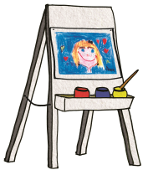
Shipping Form A
INTERNAL USE ONLY:
CODE:
RECV’D BY:
DATE:
Single Step See Before You Buy Program
Artwork Shipment
Organization Information: Please complete all information
This form MUST accompany your shipment.
Organization: |  | School Account Code:
Address:
City: | State: |  | Zip:
Coordinator: |  | Phone:
Please note any weekdays you will be closed:

Artwork Details: Please complete all information
Number of artworks sent: Number of classes:

- Please note that if the organization is unable to complete the program and send in orders, the organization will be responsible for paying 100% of the See Before You Buy magnets produced.

- Original Works cannot accept any late artwork for the magnet phase of the program. If a child misses the magnet phase of the program, they are still eligible to submit an order for any product during the Order Phase of the program.

For more details or for copies of other forms, visit the Customer Care Center on our website
www.originalworks.com/index.php/customer-care/
Send to: ORIGINAL WORKS
Building 1 54 Caldwell Road Stillwater, NY 12170 800-421-0020 cs@originalworks.com

