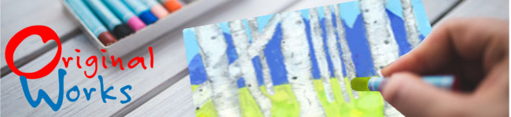
Again and again we hear from coordinators and art teachers how much families love us!

Why? The answer is quite simple. We aren’t your typical fundraising business. We focus on celebrating creativity and capturing a special moment in the lives of children across the world.

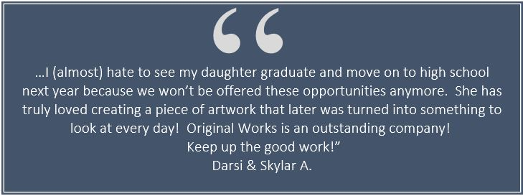
Ready to offer a program that families will support and ask for year after year? Click here and complete a quick online sign-up form. Or respond to this email and I’ll start preparing your schedule.

With your success in mind,

Representative Name
Territory Representative

Email
Phone #
www.originalworks.com

