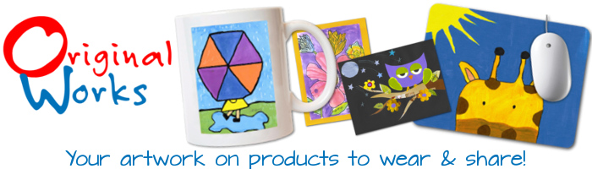
3,845 Principals can’t be wrong…
As the #1 art based fundraiser in the country for over 25 years, Original Works knows that school budgets are stretched like never before ...
... And so do the 3,845 school principals whose schools ran an Original Works program this past school year.

While study after study links exposure to the arts to a more effective, well rounded education for our children, funding for the arts continues to dwindle.

Which is why our programs are designed to encourage student creativity and self-esteem. All to assist you in more fully funding your budget.

Interested in joining the 3,845 principals already running Original Works? You are just 60 seconds away from starting one of our art based fundraisers!

Click here to sign-up online or respond to my email and I’ll be happy to explain your options and how we can help your Arts’ budget.

